**Chirag H M – 6373750(superset id)**

**Exercise 1: Configuring a Basic Spring Application**

**Scenario:**

Your company is developing a web application for managing a library. You need to use the Spring Framework to handle the backend operations.

**Steps:**

1. **Set Up a Spring Project:**
   * Create a Maven project named **LibraryManagement**.
   * Add Spring Core dependencies in the **pom.xml** file.
2. **Configure the Application Context:**
   * Create an XML configuration file named **applicationContext.xml** in the **src/main/resources** directory.
   * Define beans for **BookService** and **BookRepository** in the XML file.
3. **Define Service and Repository Classes:**
   * Create a package **com.library.service** and add a class **BookService**.
   * Create a package **com.library.repository** and add a class **BookRepository**.
4. **Run the Application:**
   * Create a main class to load the Spring context and test the configuration.

**Solution:**

Create a new Maven project named **LibraryManagement.**

Add the spring core dependency in the pom.xml file.

<dependencies>

<!-- Spring Core -->

<dependency>

<groupId>org.springframework</groupId>

<artifactId>spring-context</artifactId>

<version>5.3.36</version>

</dependency>

</dependencies>

**Create XML Configuration File**

Path: src/main/resources/applicationContext.xml

<?xml version="1.0" encoding="UTF-8"?>

<beans xmlns="http://www.springframework.org/schema/beans"

xmlns:xsi="http://www.w3.org/2001/XMLSchema-instance"

xsi:schemaLocation="http://www.springframework.org/schema/beans

https://www.springframework.org/schema/beans/spring-beans.xsd">

<!-- Repository Bean -->

<bean id="bookRepository" class="com.library.repository.BookRepository"/>

<!-- Service Bean -->

<bean id="bookService" class="com.library.service.BookService">

<property name="bookRepository" ref="bookRepository"/>

</bean>

</beans>

**Define Service and Repository Classes:**

**BookRepository Class**

Path: src/main/java/com/library/repository/BookRepository.java

package com.library.repository;

public class BookRepository {

public void saveBook(String title) {

System.***out***.println("Saving book: " + title);

}

}

### BookService Class

Path: src/main/java/com/library/service/BookService.java

package com.library.service;

import com.library.repository.BookRepository;

public class BookService {

private BookRepository bookRepository;

// Setter for Dependency Injection

public void setBookRepository(BookRepository bookRepository) {

this.bookRepository = bookRepository;

}

public void addBook(String title) {

System.***out***.println("BookService: Adding book");

bookRepository.saveBook(title);

}

}

### Main Class

Path: src/main/java/com/library/MainApp.java

package com.library;

import com.library.service.BookService;

import org.springframework.context.ApplicationContext;

import org.springframework.context.support.ClassPathXmlApplicationContext;

public class MainApp {

public static void main(String[] args) {

ApplicationContext context = new ClassPathXmlApplicationContext("applicationContext.xml");

BookService bookService = context.getBean("bookService", BookService.class);

bookService.addBook("The Alchemist");

}

}

Output:

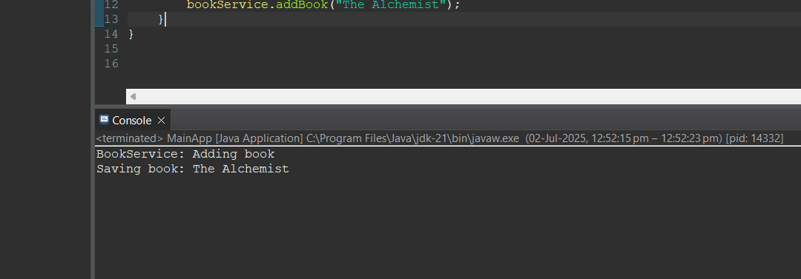

**Exercise 2: Implementing Dependency Injection**

**Scenario:**

In the library management application, you need to manage the dependencies between the BookService and BookRepository classes using Spring's IoC and DI.

**Steps:**

1. **Modify the XML Configuration:**
   * Update **applicationContext.xml** to wire **BookRepository** into **BookService**.
2. **Update the BookService Class:**
   * Ensure that **BookService** class has a setter method for **BookRepository**.
3. **Test the Configuration:**
   * Run the **LibraryManagementApplication** main class to verify the dependency injection.

Solution:

Modify the xml code as follow in the previous created project itself:

<?xml version="1.0" encoding="UTF-8"?>

<beans xmlns="http://www.springframework.org/schema/beans"

xmlns:xsi="http://www.w3.org/2001/XMLSchema-instance"

xsi:schemaLocation="http://www.springframework.org/schema/beans

https://www.springframework.org/schema/beans/spring-beans.xsd">

<!-- Repository Bean -->

<bean id="bookRepository" class="com.library.repository.BookRepository"/>

<!-- Service Bean with DI using setter -->

<bean id="bookService" class="com.library.service.BookService">

<property name="bookRepository" ref="bookRepository"/>

</bean>

</beans>

BookService.java

package com.library.service;

import com.library.repository.BookRepository;

public class BookService {

private BookRepository bookRepository;

// Required setter for Spring DI

public void setBookRepository(BookRepository bookRepository) {

this.bookRepository = bookRepository;

}

public void addBook(String title) {

System.***out***.println("BookService: Adding book");

bookRepository.saveBook(title);

}

}

.

MainApp.java

package com.library;

import com.library.service.BookService;

import org.springframework.context.ApplicationContext;

import org.springframework.context.support.ClassPathXmlApplicationContext;

public class MainApp {

public static void main(String[] args) {

// Load Spring context from applicationContext.xml

ApplicationContext context = new ClassPathXmlApplicationContext("applicationContext.xml");

// Get BookService bean

BookService bookService = context.getBean("bookService", BookService.class);

// Test the service method

bookService.addBook("Clean Code");

}

}

Output:

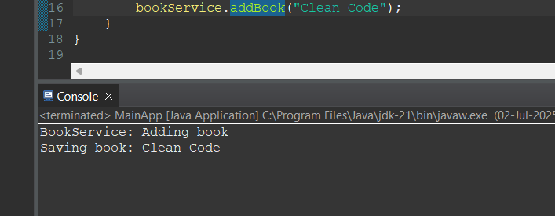

**Exercise 4: Creating and Configuring a Maven Project**

**Scenario:**

You need to set up a new Maven project for the library management application and add Spring dependencies.

**Steps:**

1. **Create a New Maven Project:**
   * Create a new Maven project named **LibraryManagement**.
2. **Add Spring Dependencies in pom.xml:**
   * Include dependencies for Spring Context, Spring AOP, and Spring WebMVC.
3. **Configure Maven Plugins:**
   * Configure the Maven Compiler Plugin for Java version 1.8 in the pom.xml file.

Solution:

Create a New Maven Project named LibraryManagement_

Add the following dependencies into the pom.xml code :

<dependencies>

<!-- Spring Context -->

<dependency>

<groupId>org.springframework</groupId>

<artifactId>spring-context</artifactId>

<version>5.3.36</version>

</dependency>

<!-- Spring AOP -->

<dependency>

<groupId>org.springframework</groupId>

<artifactId>spring-aop</artifactId>

<version>5.3.36</version>

</dependency>

<!-- Spring WebMVC -->

<dependency>

<groupId>org.springframework</groupId>

<artifactId>spring-webmvc</artifactId>

<version>5.3.36</version>

</dependency>

<!-- Optional: Servlet API (needed for Spring WebMVC) -->

<dependency>

<groupId>javax.servlet</groupId>

<artifactId>javax.servlet-api</artifactId>

<version>4.0.1</version>

<scope>provided</scope>

</dependency>

</dependencies>

Configure Maven Compiler Plugin for Java 1.8

Add the following build section into the pom.xml

<build>

<plugins>

<!-- Maven Compiler Plugin -->

<plugin>

<groupId>org.apache.maven.plugins</groupId>

<artifactId>maven-compiler-plugin</artifactId>

<version>3.10.1</version>

<configuration>

<source>1.8</source>

<target>1.8</target>

</configuration>

</plugin>

</plugins>

</build>